Features

- Extra high radiant power and radiant intensity
- Angle of Intensity ±20 °
- High reliability
- Low forward voltage
- Suitable for high pulse current operation
- Standard (∮5 mm) package
- Peak wavelength λ = 940 nm
- Good spectral matching to Si photodetectors
- Lead-free component
- Component in accordance to RoHS

Applications

  - Infrared remote control units with high power requirements
  - Free air transmission systems
  - Infrared source for optical counters and card readers
  - IR source for smoke detectors

Absolute Maximum Ratings

T_{amb} = 25 °C, unless otherwise specified
Parameter | Test condition | Symbol | Value | Unit
Reverse Voltage |  | V_{R} | 5 | V
Forward current |  | I_{F} | 100 | mA
Peak Forward Current | t_{p} /T=0.5, t_{p} = 100μs | I_{FM} | 200 | mA
Surge Forward Current | t_{p} = 100μs | I_{FSM} | 1.5 | A
Power Dissipation |  | P_{V} | 100 | mW
Junction Temperature |  | T_{j} | 100 | °C
Operating Temperature Range |  | T_{amb} | - 55 to + 100 | °C
Storage Temperature Range |  | T_{stg} | - 55 to + 100 | °C
Soldering Temperature | t ≤ 5 sec, 2 mm from case | T_{sd} | 260 | °C

Characteristics
IR5123C-114-3.6

T_{amb} = 25 °C, unless otherwise specified
Parameter | Test condition | Symbol | Min | Typ. | Max | Unit
Forward Voltage | I_{F} = 50 mA, t_{p} = 20 ms | V_{F} |  | 1.2 | 1.4 | V
Forward Voltage | I_{F} = 0.5 A, t_{p} = 100μs | V_{F} |  | 1.9 | 2.5 | V
Reverse Current | V_{R} = 5 V | I_{R} |  |  | 10 | A
Junction capacitance | V_{R} = 0 V, f = 1 MHz, E = 0 | C_{j} |  | 25 |  | pF
Radiant Intensity | I_{F} = 50 mA, t_{p} = 20 ms | I_{e} | 60 | 90 |  | mW/sr
Radiant Intensity | I_{F} = 0.5 A, t_{p} = 100μs | I_{e} | 320 | 580 |  | mW/sr
Radiant Intensity | I_{F} = 50 mA, t_{p} = 20 ms, | I_{e} |  | 58 |  | mW/sr
Angle of Intensity | I_{F} = 50 mA, E_{e} > 7 mW/cm²,r = 50 cm | θ |  | ±20 |  | deg
Radiant Power | I_{F} = 50 mA, t_{p} = 20 ms | φe |  | 20 |  | mW
Peak Wavelength | I_{F} = 100 mA | λ_{p} |  | 940 |  | nm
Spectral Bandwidth | I_{F} = 100 mA | Δλ |  | 50 |  | nm
Temp. Coefficient ofλ_{p} | I_{F} = 100 mA | TKλp |  | 0.2 |  | nm/K
Rise Time | I_{F} = 100 mA | t_{r} |  | 800 |  | ns
Fall Time | I_{F} = 100 mA | t_{f} |  | 800 |  | ns

Typical Characteristics
(T_{amb} = 25 °C unless otherwise specified)
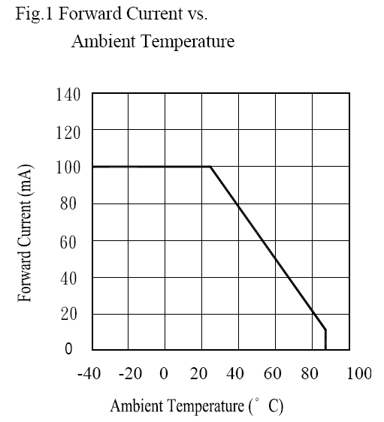
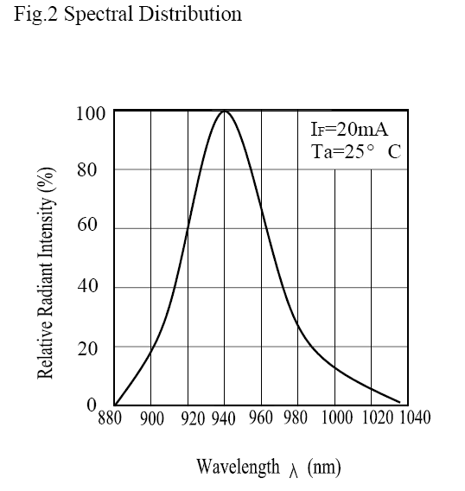

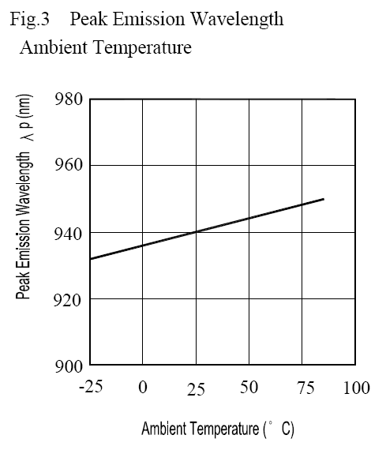
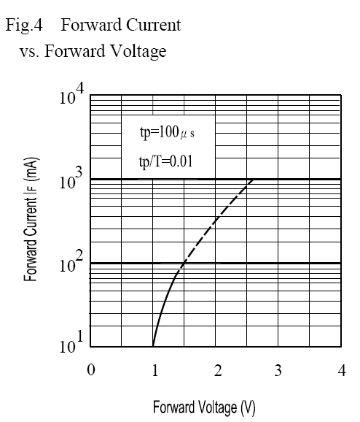
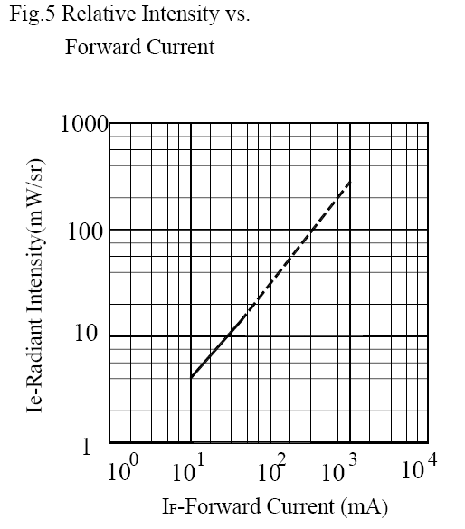
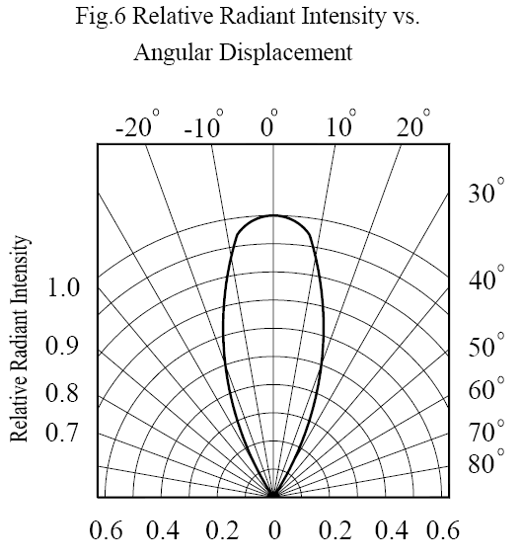
IR5123C-114-3.6

